JIRA
EX01- KAMBAN BOARD
AIM:
To design and organize project activities using a Kanban board in Jira for effective task visualization and workflow management.
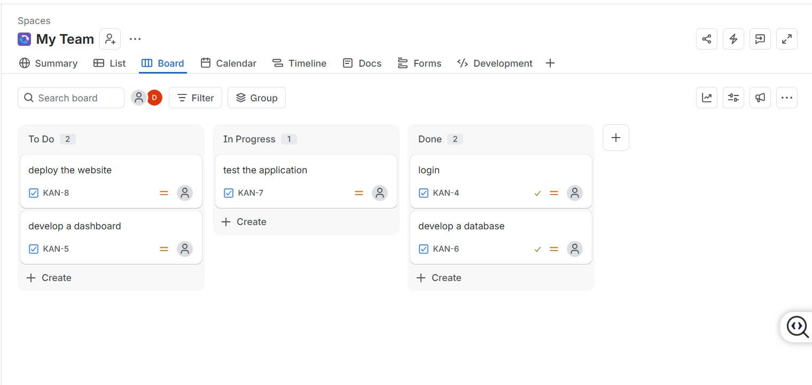

RESULT:
Thus, a Kanban board was successfully created in Jira, and the project tasks were organized according to their workflow status.

EX09- LIBRARY MANAGEMENT USING MOSCOW
AIM
To implement a Library Management project in Jira using the MoSCoW prioritization technique to classify and manage project requirements.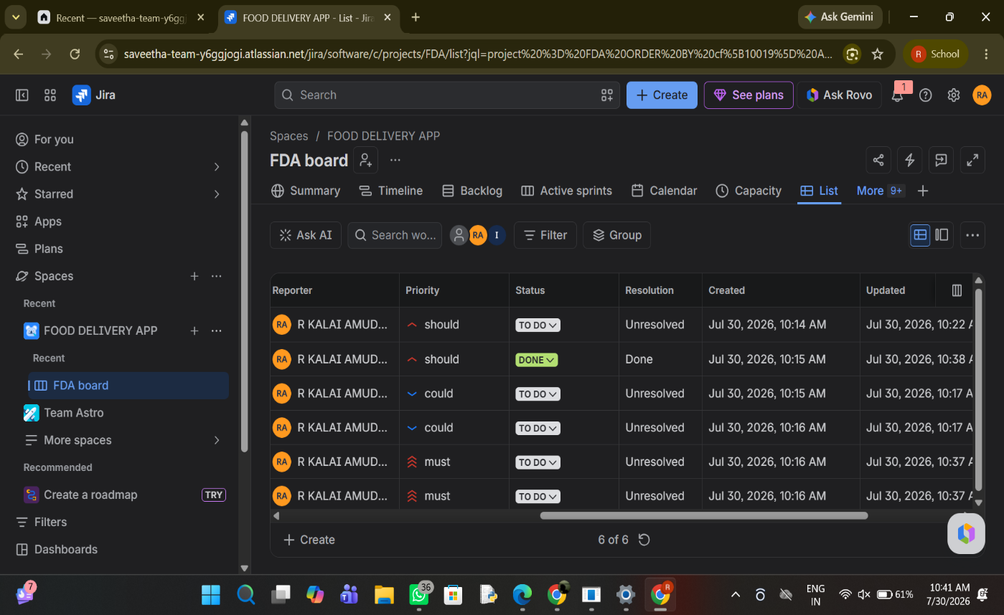
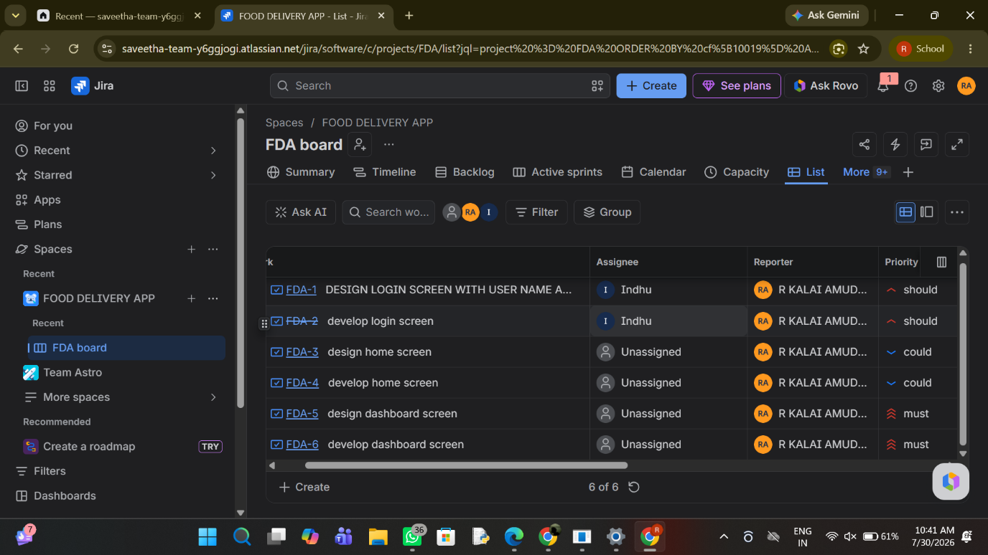

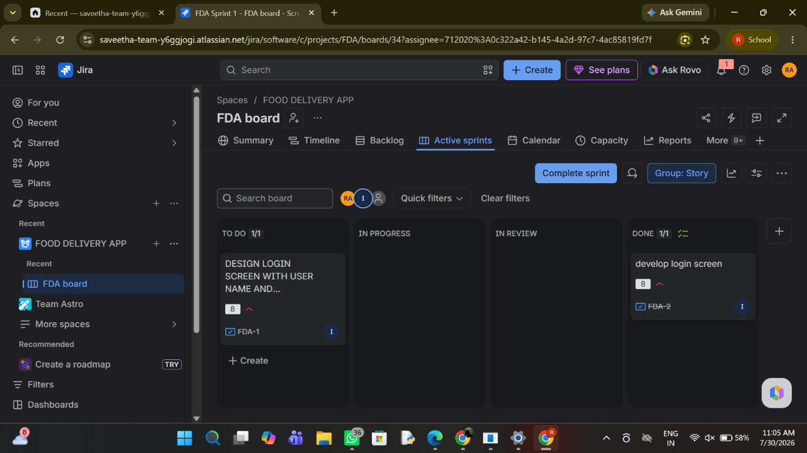

Result
Thus, the Library Management project was successfully organized in Jira by prioritizing requirements and managing them through the Scrum workflow.

EX11 - LIBRARY MANAGEMENT WITH CONFLUENCE
AIM:
To integrate Jira with Confluence for documenting and coordinating the development activities of a Library Management System.

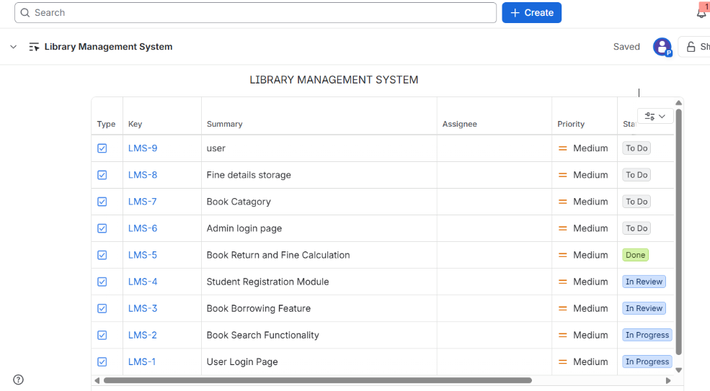

RESULT:
Thus, Jira tasks were successfully connected with the Confluence workspace, enabling better documentation and monitoring of the Library Management System.

EX12- Task Management System
AIM:
To create a Jira-based task management system for assigning, organizing, and monitoring tasks within a small development team.
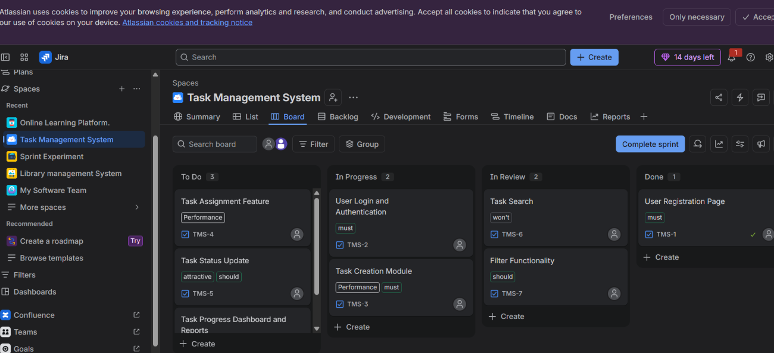

RESULT:
Thus, a Task Management System was successfully designed in Jira, with tasks organized according to their respective progress and status.
EX13- ONLINE LEARNING PLATFORM.
AIM:
To develop an Online Learning Platform project in Jira by organizing learning-related features and tracking their development progress.

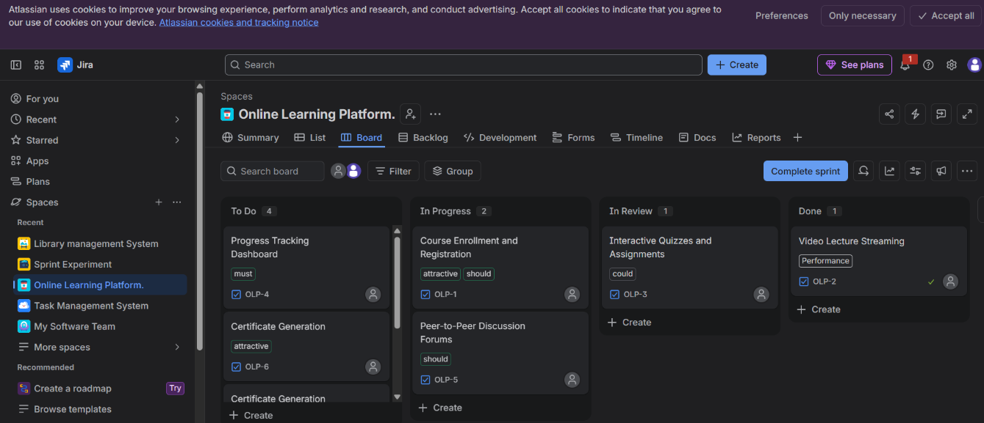

RESULT:
Thus, an Online Learning Platform project was successfully created in Jira, and its major activities were arranged and monitored through the project board.

